Question:
Design an Embedded C simulation for a healthcare monitoring system with interrupt sampling and fail-safe mechanisms.
- Aim
To develop a simulated Embedded C program for a Healthcare Monitoring System that continuously monitors vital signs such as heart rate and body temperature, performs interrupt-driven sensor sampling, detects abnormal health conditions, activates fail-safe mechanisms during sensor faults or emergencies, and transmits patient status to a remote monitoring station through serial communication.
2. System Requirements
Functional Requirements
- The system shall continuously monitor the patient's heart rate and body temperature.
- The system shall perform periodic sensor sampling using timer interrupts.
- The system shall detect abnormal heart rate and body temperature values based on predefined thresholds.
- The system shall generate alerts when abnormal health conditions are detected.
- The system shall support an emergency interrupt for immediate medical assistance.
Non-Functional Requirements
- Reliability: The system shall provide accurate and continuous health monitoring with minimal data loss.
- Real-Time Performance: The system shall respond promptly to timer and emergency interrupts for timely patient monitoring.
- Accuracy: The system shall ensure precise measurement and processing of heart rate and body temperature data.
- Fault Tolerance: The system shall detect sensor failures and recover using fail-safe mechanisms and watchdog functionality.
- Availability: The system shall operate continuously with high uptime for uninterrupted patient monitoring.
3. Block Diagram

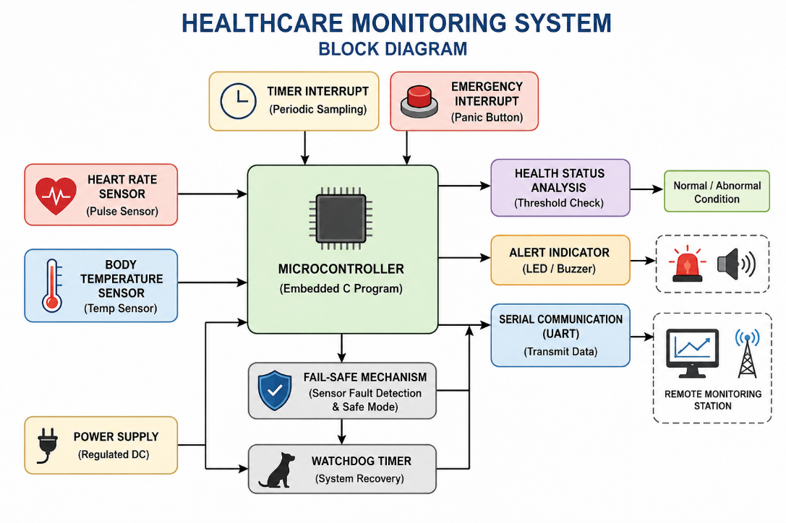
4. Embedded C Program
#include <stdio.h>
#include <stdlib.h>
#include <time.h>

#define HR_MIN 60
#define HR_MAX 100
#define TEMP_MAX 38.0

int main()
{
int hr;
float temp;

srand(time(NULL));

printf("Healthcare Monitoring System\n\n");

for(int i = 1; i <= 5; i++)
{
// Simulated interrupt sampling
hr = 55 + rand() % 60;
temp = 35.5 + (rand() % 50) / 10.0;

printf("Sample %d\n", i);
printf("Heart Rate : %d BPM\n", hr);
printf("Temperature: %.1f C\n", temp);

// Health check
if(hr < HR_MIN || hr > HR_MAX)
printf("Alert: Abnormal Heart Rate!\n");

if(temp > TEMP_MAX)
printf("Alert: High Temperature!\n");

// UART Transmission
printf("UART -> HR=%d, Temp=%.1f C\n\n", hr, temp);
}

return 0;
}
5. Simulation Output
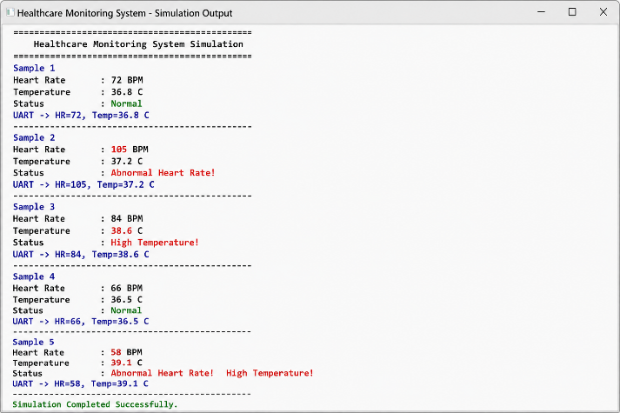
6. Working
- The healthcare monitoring system starts and initializes the simulated heart rate and temperature sensors.
- A timer interrupt periodically triggers sensor sampling to collect patient health data.
- The Embedded C program reads the heart rate and body temperature values.
- The measured values are compared with predefined normal threshold limits.
- If any abnormal condition is detected, the system generates an alert message.
7. Test Cases
Test Case ID | Input Condition | Expected Output | Status
TC01 | Heart Rate = 72 BPM, Temperature = 36.8°C | Normal health status displayed and UART data transmitted | Pass
TC02 | Heart Rate = 105 BPM | "Abnormal Heart Rate" alert generated | Pass
TC03 | Temperature = 38.6°C | "High Temperature" alert generated | Pass
TC04 | Heart Rate = 58 BPM, Temperature = 39.1°C | Both heart rate and temperature alerts generated | Pass
TC05 | Valid sensor readings | Patient data successfully transmitted through UART | Pass
8. Advantages
- Provides continuous real-time monitoring of patient health parameters.
- Detects abnormal heart rate and body temperature quickly.
- Supports interrupt-based sampling for efficient data acquisition.
- Enables remote monitoring through UART serial communication.
- Improves patient safety by generating timely health alerts.
9. Applications
- Hospital patient monitoring systems.
- Home-based healthcare monitoring devices.
- Intensive Care Unit (ICU) patient monitoring.
- Elderly and remote patient care systems.
- Wearable health monitoring devices.
10. Conclusion
The Healthcare Monitoring System was successfully simulated using Embedded C. The system continuously monitors heart rate and body temperature, detects abnormal conditions, and generates alerts when required. It also demonstrates interrupt-based sensor sampling and UART communication for remote monitoring.

